  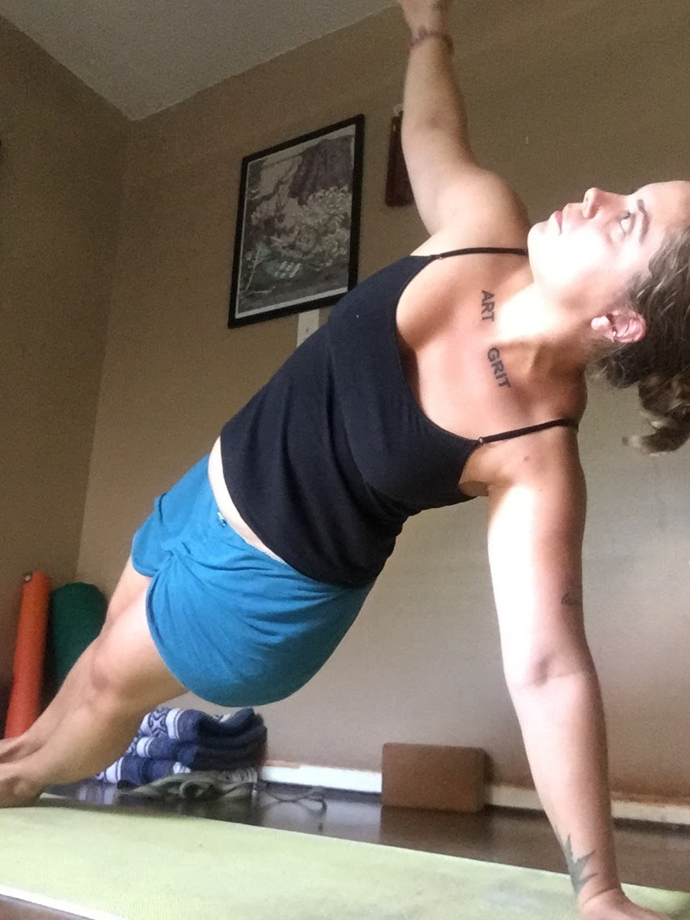
    - Embodied Creativity
  Workshop
  For Artists and Yogis of All Levels
  Blockage is a normal part of artistic life. There are actions you can take to alleviate your frustration with an inability to create. Embodied Creativity features a combination of asanas and exploratory writing prompts which allow artists/writers of all stripes to relieve their sense of stagnation. Whether you are an experienced artist struggling with their work, or a beginner trying to get the courage to start that new project, this workshop is for you.
  
  Sunday,
  November 13th
  1:30 – 3:30 p.m.
  $30 Non-Members
  $25 Members
  Asana sequencing is designed for all levels. Beginning yogis (and artists) welcome!
  Allyson Whipple
  is a poet who has been practicing yoga for nine years. She is the author of two poetry collections and teaches at ACC. Her favorite pose is headstand. (Don’t worry, she won’t make you do that in the workshop!)

